Assignment: Recursion, Recurrence Relations and Divide & Conquer

1. **Solve recurrence relation using three methods**:

Write recurrence relation of below pseudocode that calculates 𝑥𝑛, and solve the recurrence relation using three methods that we have seen in the explorations.

|  |
| --- |
| power2(x,n): if n==0:  return 1 if n==1:  return x  if (n%2)==0:  return power2(x, n//2) * power2(x,n//2)  else:  return power2(x, n//2) * power2(x,n//2) * x |

1. Using substitution method:

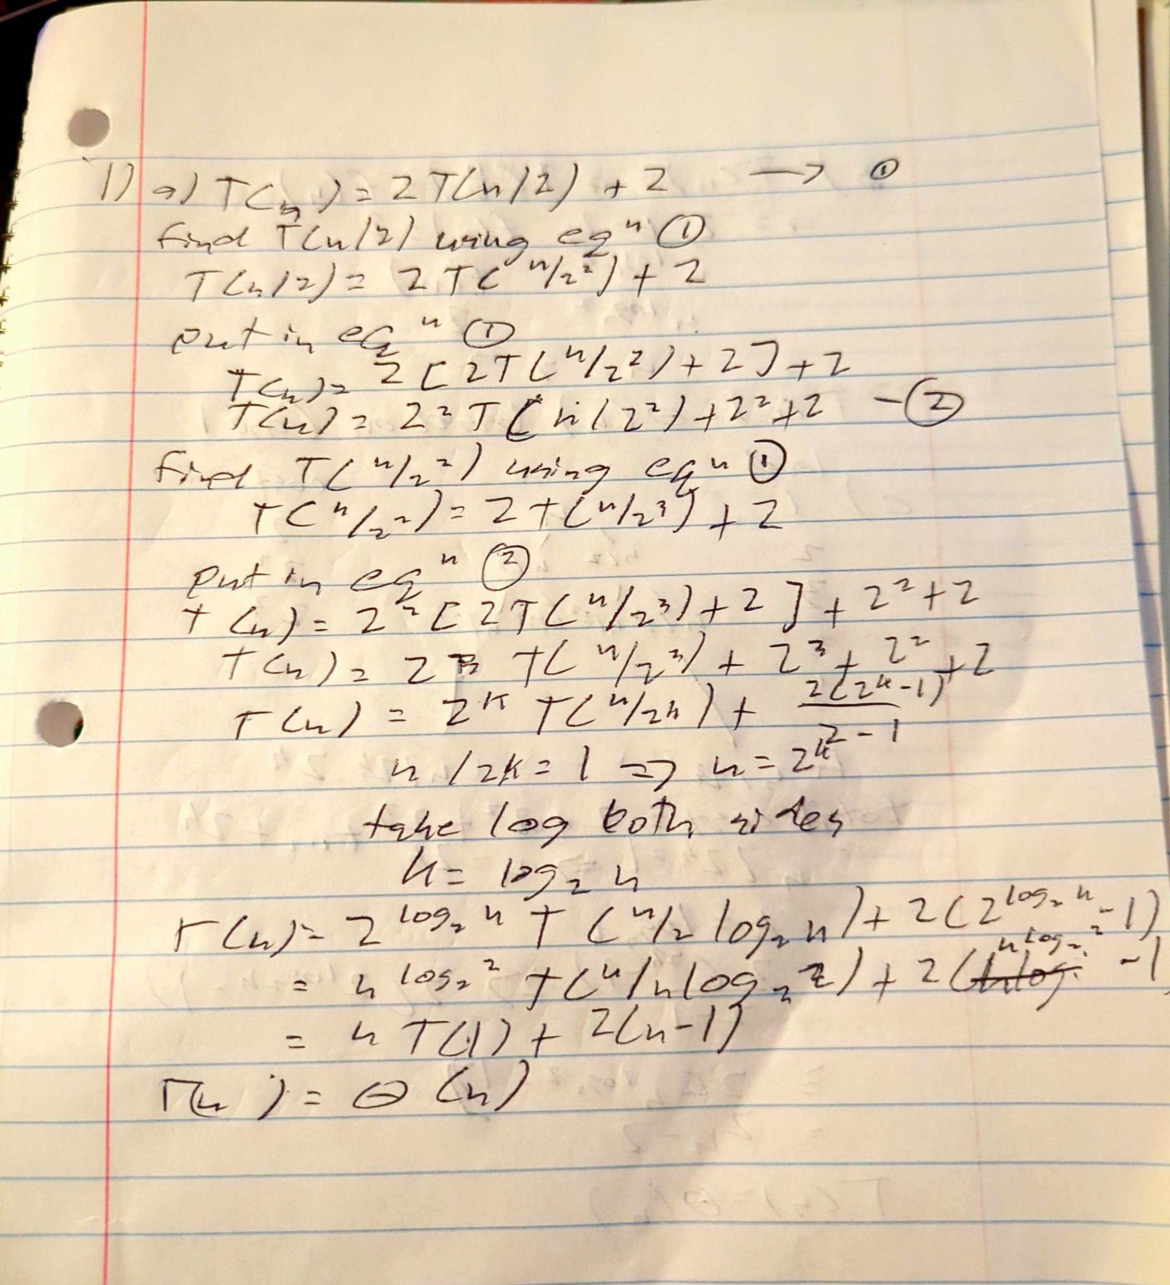

1. Using master method:

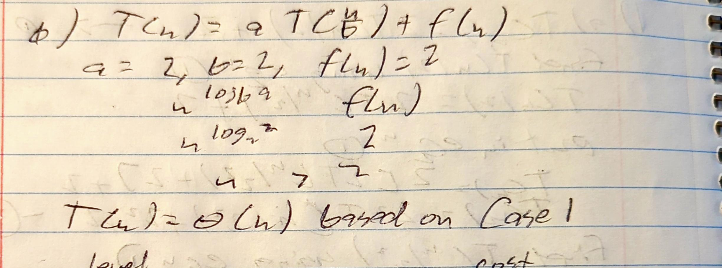

1. Recursion-tree method:

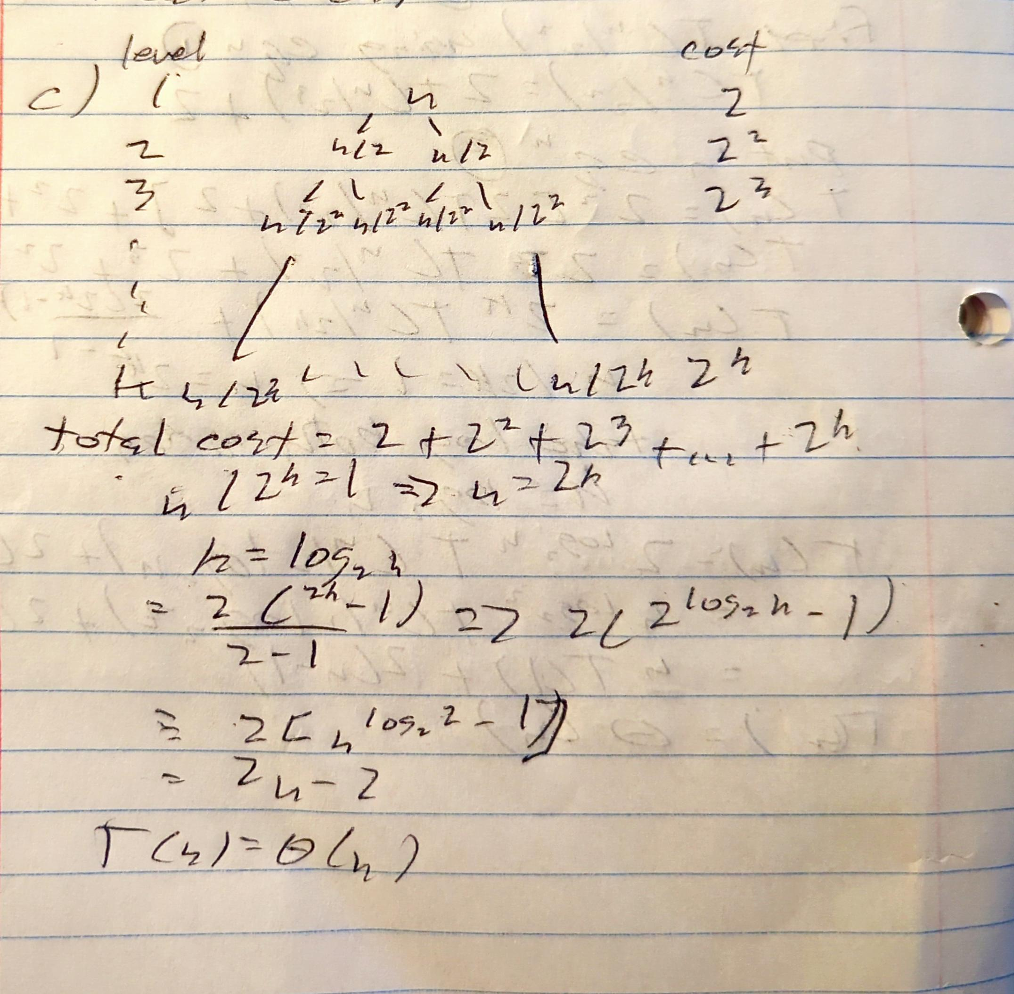

1. **Solve recurrence relation using any one method**:

Find the time complexity of the recurrence relations given below using any one of the three methods discussed in the module. Assume base case T(0)=1 or/and T(1) = 1.

1. 𝑇(𝑛) = 4𝑇 ( 𝑛/2 )+ 𝑛

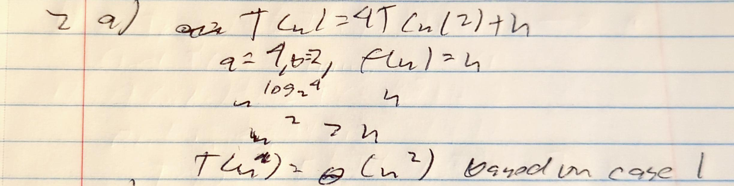

1. 𝑇(𝑛) = 2𝑇 ( 𝑛/4 ) + 𝑛2

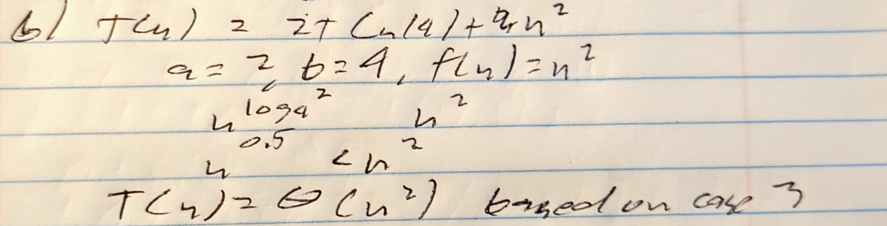

1. **Implement an algorithm using divide and conquer technique**: Given two sorted arrays of size m and n respectively, find the element that would be at the kth position in combined sorted array.

* 1. Write a pseudocode/describe your strategy for a function kthelement(Arr1, Arr2, k) that uses the concepts mentioned in the divide and conquer technique. The function would take two sorted arrays Arr1, Arr2 and position k as input and returns the element at the kth position in the combined sorted array.
     1. Function kethElement(Arr1, Arr2, k):

if Arr1 is empty:

return Arr2[k - 1]

if Arr2 is empty:

return Arr1[k - 1]

if k is 1:

return min(Arr1[0], Arr2[0])

mid1 = min(length(Arr1), k // 2)

mid2 = min(length(Arr2), k // 2)

if Arr1[mid1 - 1] < Arr2[mid2 - 1]:

return kthelement(Arr1[mid1:], Arr2, k - mid1)

else:

return kthelement(Arr1, Arr2[mid2:], k - mid2)

* 1. Implement the function kthElement(Arr1, Arr2, k) that was written in part a. Name your file **KthElement.py**

Examples:

Arr1 = [1,2,3,5,6] ; Arr2= [3,4,5,6,7] ; k= 5

Returns: 4

Explanation: 5th element in the combined sorted array [1,2,3,3,4,5,5,6,6,7] is 4